SIMPLE SOFTWARE DESIGN DOCUMENT
Project ManageWare: Hardware Purchase and Inventory Management System
Design Version: 1.0
Based on SRS: SRS-PMW-2026-001
Standard Reference: IEEE Std 830-1998
1. CONTEXT
Project ManageWare solves the problem of inefficient tracking, procurement, and lifecycle management of hardware assets across multiple real estate properties. The system centralizes inventory tracking, asset tagging, purchase order generation, and maintenance monitoring through a cloud-hosted web platform.
The main stakeholders include Property Managers (asset tracking and requests), Finance Directors (budget approval and purchase orders), and IT Specialists (maintenance and inventory control).
The system scope integrates with existing financial software and runs on existing infrastructure. It provides automated procurement, real-time inventory tracking, and reporting while excluding physical asset purchase and native mobile applications.

2. ARCHITECTURE
System Architecture Diagram (Simple Component View)
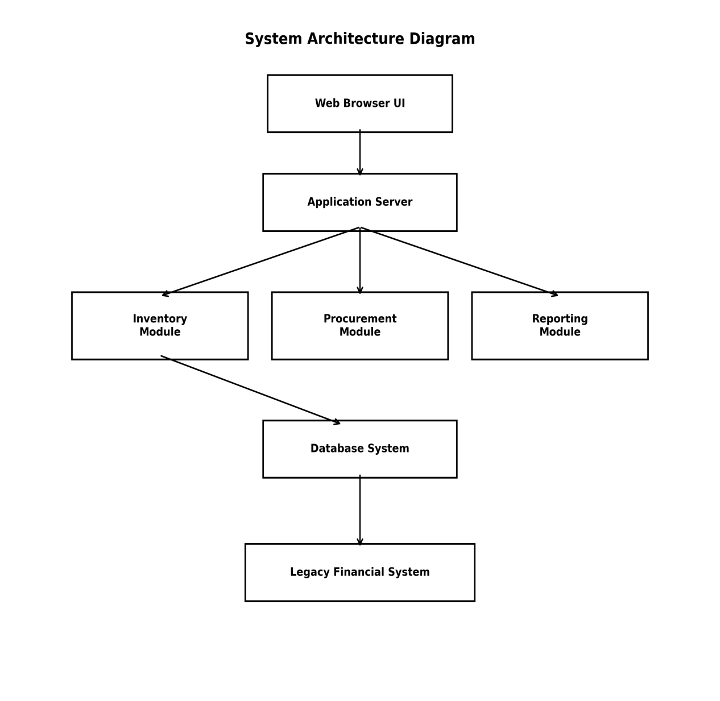

Main Components

Web Interface

- Mobile-responsive dashboard
- Property mapping visualization
- Asset lifecycle updates
- Role-based access control

Application Server

- Business logic processing
- Authentication and authorization
- Request handling
- API management

Inventory Management Module

- Asset tracking
- Unique ID generation
- Lifecycle management
- Inventory threshold monitoring

Procurement Module

- Purchase order generation (PDF)
- Financial system integration
- Budget synchronization

Database System

- Stores asset records
- Audit logs
- Financial data
- Reporting data

Component Communication

- Web User Interface communicates with Application Server via HTTP requests.
- Application Server interacts with database for storage and retrieval.
- Procurement Module integrates with legacy financial system APIs.
- System supports cloud migration to environments like Amazon Web Services or Microsoft Azure.

3. DATA
Simple ERD (Main Entities)
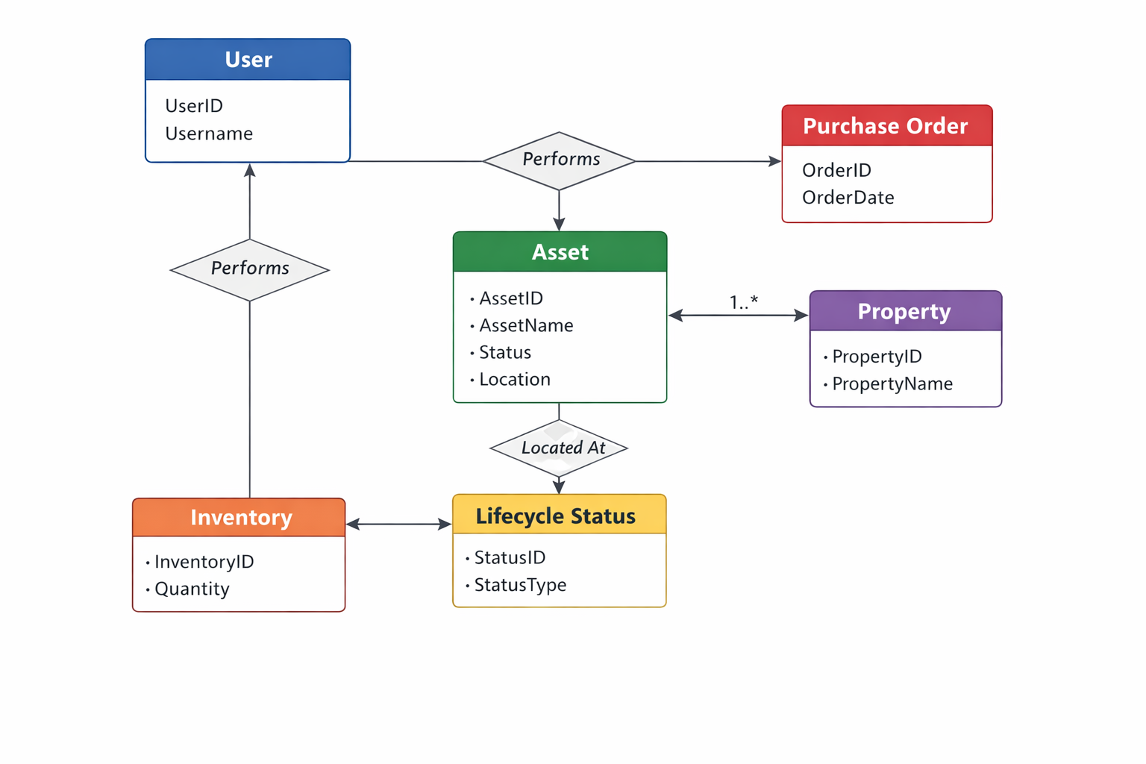

Key Data Relationships

- A User performs one or many approvals and asset updates.

- A Property contains multiple hardware assets.

- Each Asset has one unique ID and lifecycle status.

- Purchase Orders are generated after financial approval.

- Inventory tracks asset quantities and thresholds.

- Audit logs record all changes.

4. MAIN PROCESS
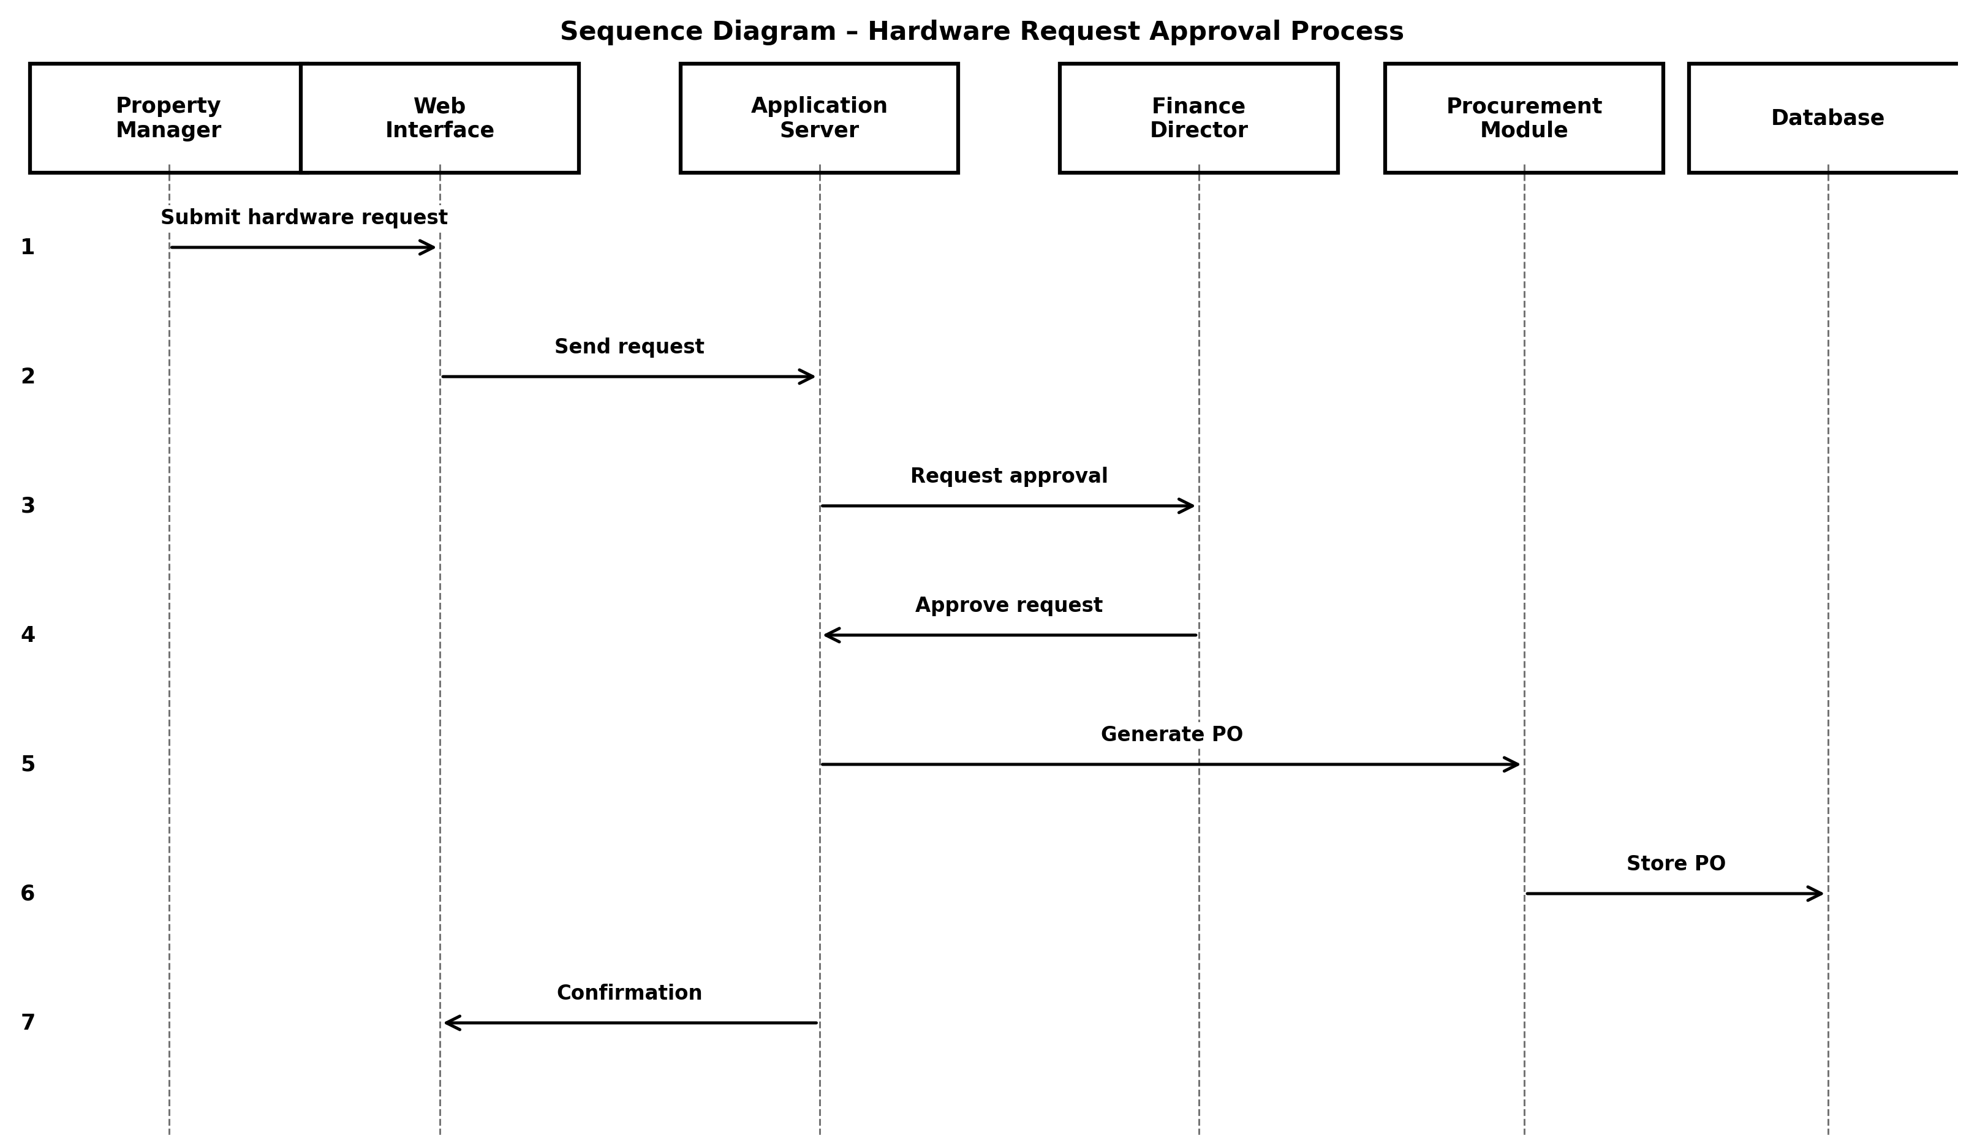
Process Flow

- Property manager submits hardware request via the Web interface to the application server.
- Finance director reviews and approves the request.
- System generates purchase order automatically.
- Inventory is updated in the database.
- Database returns updated asset information to the application server.
- Results are displayed on the user dashboard.
- System confirms completion.

5. DECISIONS & CONSTRAINTS

Key Design Decisions

- Cloud-hosted architecture for scalability.
- Role-based authentication for security.
- AES-256 encryption for data protection.
- Responsive web interface instead of native apps.
- Modular architecture for maintainability.

Constraints / Limitations

- Must operate on existing infrastructure.
- Integration with legacy financial systems is required.
- Budget limited to Ksh 350,000.
- Deadline: April 24, 2026.
- Mobile browser compatibility required.

Project: Hardware Purchase and Inventory Management System (Project ManageWare)
Design Version: 1.0
Review Date: ___________________

Approved SRS (Summary) — Project ManageWare
REQ-MW-001: Mobile responsive web interface.
REQ-MW-002: Property mapping dashboard.
REQ-MW-003: Mobile asset tagging ID support.
REQ-MW-004: Integration with legacy financial software.
REQ-MW-005: Automated purchase order generation.
REQ-MW-006: Real-time inventory tracking.
REQ-MW-007: Unique asset ID generation.
REQ-MW-008: Asset lifecycle status updates.
REQ-MW-009: Inventory threshold email alerts.
REQ-MW-010: Visual asset distribution dashboard.
REQ-MW-011: Maintain 99% inventory accuracy.
REQ-MW-012: Operate without new server hardware.
REQ-MW-013: Data encryption at rest.
REQ-MW-014: Role-based authentication.
REQ-MW-015: System availability requirement.
REQ-MW-016: System activity logging.
REQ-MW-017: Integration failure logging.
REQ-MW-018: Documented internal APIs.
REQ-PMW-019: Deployable on existing infrastructure.
REQ-MW-020: Cross-browser compatibility.
REQ-MW-021: Cloud environment portability.
REQ-MW-022: Weekly inventory accuracy reports.
REQ-MW-023: Financial variance reports.
REQ-MW-024: Asset aging reports.
REQ-MW-025: Audit trail for hardware records.
REQ-MW-026: Regional data storage compliance.

SOFTWARE COMPLETENESS VALIDATION TABLE
Req ID | Requirement Summary | Type (F/NF) | Assigned Design Component | Interface Defined? | Data Model Defined? | Verification Strategy Identified? | Status
REQ-MW-001 | Responsive web interface | NF | Web Interface | Yes | Yes
REQ-MW-002 | Property mapping dashboard | NF | Web Interface, Reporting Module | Yes | Yes
REQ-MW-003 | Mobile asset tagging ID support | NF | Inventory Module | Yes | Yes
REQ-MW-004 | Financial software integration | NF | Procurement Module | Yes | Yes
REQ-MW-005 | Automated PO generation | F | Procurement Module | Yes | Yes
REQ-MW-006 | Real-time inventory tracking | F | Inventory Module | Yes | Yes
REQ-MW-007 | Unique asset ID generation | F | Inventory Module | Yes | Yes
REQ-MW-008 | Asset lifecycle updates | F | Inventory Module | Yes | Yes
REQ-MW-009 | Inventory threshold email alerts | F | Inventory Module | Yes | Yes
REQ-MW-010 | Visual asset distribution dashboard | F | Reporting Module | Yes | Yes
REQ-MW-011 | 99% inventory accuracy | NF | Inventory Module | Yes | Yes
REQ-MW-012 | No new server hardware required | NF | Application Server | Yes | N/A
REQ-MW-013 | AES-256 encryption at rest | NF | Security Component | Yes | Yes
REQ-MW-014 | Role-based authentication | NF | Authentication Service | Yes | Yes
REQ-MW-015 | 99.9% availability | NF | Application Server | Yes | N/A
REQ-MW-016 | System activity logging | NF | Logging Service | Yes | Yes
REQ-MW-017 | Integration failure logging | NF | Logging Service | Yes | Yes
REQ-MW-018 | Internal API documentation | NF | API Layer | Yes | N/A
REQ-PMW-019 | Deployable on existing infrastructure | NF | Application Server | Yes | N/A
REQ-MW-020 | Cross-browser compatibility | NF | Web Interface | Yes | N/A
REQ-MW-021 | Cloud migration support | NF | Deployment Architecture | Yes | N/A
REQ-MW-022 | Weekly inventory reports | NF | Reporting Module | Yes | Yes
REQ-MW-023 | Financial variance reports | NF | Reporting Module | Yes | Yes
REQ-MW-024 | Asset aging reports | NF | Reporting Module | Yes | Yes
REQ-MW-025 | Non-editable audit trail | NF | Database, Logging Service | Yes | Yes
REQ-MW-026 | Regional data storage compliance | NF | Database System | Yes | Yes

